Personal, Relevant Background, and Future Goals Statement
Intellectual Merit
My ability to advance knowledge emerges from a pattern of identifying critical bottlenecks at the intersection of hardware, software, and machine learning, then acquiring the expertise to solve them. This began when I joined Dr. Yi Wang's Integrated Multiphysics and Systems Engineering Laboratory as an undergraduate with a primarily mechanical engineering background. The lab lacked a flexible interface for our Furuno radar systems, so I built an end-to-end control pipeline from radome to computer with an intuitive GUI that became the backbone of our current research. This pipeline later enabled the development of multi-gain, high-dynamic-range radar techniques (Fig. 1).
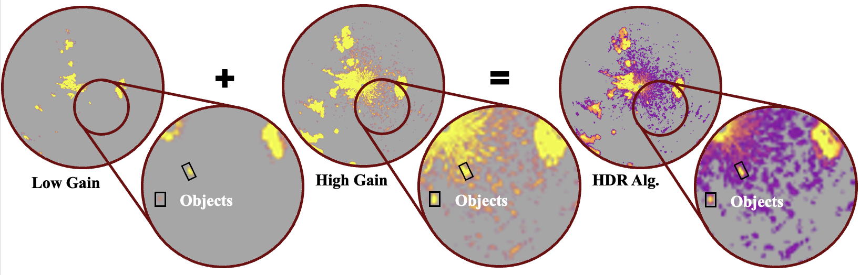
Figure 1. High-dynamic-range (HDR) radar fusion. Combine low-gain and high-gain returns to recover small-object signatures that are invisible in single-gain imaging.
My vision for graduate school centers on physics-aware radar-camera perception with radar-guided auto-labeling – addressing the critical gap in robust multi-modal detection of small maritime targets in littoral environments. I integrate physics priors directly into model loss functions, encouraging range/bearing consistency between radar and image features while using small-object queries and oversampling to handle challenging cases. These goals build directly on the interdisciplinary skill set I developed across prior projects, culminating in my current radar-camera fusion and auto-labeling framework (Fig. 2).
Figure 2. Integration of prior research projects, technical skills, and project-specific applications leading to the development of my current research agenda.
My baselines show commercial systems achieve ~93% land discrimination and ~74% boat-versus-buoy accuracy; my targets are ≥98% land-versus-object accuracy and ≥95% boat-versus-buoy discrimination using ≤10% of the labels, while maintaining ≤100ms latency on Jetson Orin edge devices. These numbers represent the performance thresholds required for real-world autonomous maritime operations where safety depends on reliable perception in adverse conditions. These performance thresholds and my progress toward them are summarized in Fig. 3.
Figure 3. Performance comparison of commercial SOTA baselines, current progress, and target objectives for land–object discrimination, boat–buoy classification, and edge inference latency.

Broader Impacts
My commitment to broader impacts flows from my own non-traditional educational path. Homeschooled until age 15, I started college with significant gaps in writing and basic science while working multiple jobs to cover rent. I had to invent my own structure for success, scoping problems and building toolchains without a roadmap.
This knowledge transfer multiplies our lab's impact, as each student I train becomes capable of training the next cohort. I take particular pride in seeing them present their work, knowing I've helped transform promising students into confident researchers. My teaching experience scales this impact across the university. These mentoring and teaching experiences feed directly into a structured pipeline that supports student researchers and strengthens our academic community (Fig. 4).
Figure 4. Teaching, mentoring, and governance activities mapped to the educational and community outcomes they enabled.
The societal relevance of my research amplifies these impacts. Maritime autonomy sits at the intersection of national security and public safety. My work on small-craft detection under littoral clutter directly addresses challenges faced by the Navy, Coast Guard, and NOAA – enabling better coastal surveillance, search-and-rescue operations, and marine ecosystem monitoring.
I maintain bi-annual meetings with NIWC (Naval Information Warfare Center) and plan collaborations with NOAA, ensuring my research serves real-world missions. The auto-labeling pipeline I'm developing will reduce human annotation time from 60 to 20 seconds per frame, dramatically lowering the cost of creating training datasets for maritime AI systems. My research, outreach, and partnerships operate within a broad ecosystem of collaborators and stakeholders, shown in Fig. 5.
I will establish a benchmark release process that enables external researchers to validate and build upon our methods, fostering healthy competition and rapid progress in the field. I'll continue K-12 outreach with periodic workshops at local high schools, using hands-on demos to show that engineering is accessible and exciting.
Figure 5. Ecosystem of collaborators and stakeholders across academia, government, industry, and outreach communities, illustrating the flows central to my broader impacts.
Within the university, I'll organize interdisciplinary seminars bridging mechanical engineering, computer science, and marine science – breaking down departmental silos that often impede collaborative research. My career vision reflects this dual commitment to innovation and service. In five years, I aim to join a national lab like NIWC or NRL, advancing maritime sensing capabilities that directly enhance national security and public safety.
In ten years, I plan to launch a startup commercializing robust perception systems for autonomous vessels while teaching part-time – sharing both cutting-edge knowledge and practical industry insights with the next generation. This path ensures my research continues serving society while I build structured pathways for others to succeed, just as I wish I'd had starting out.
The NSF Graduate Research Fellowship would transform my ability to deliver these impacts. It would provide the financial stability to focus on ambitious research goals while dedicating substantial time to mentorship and outreach. It would connect me to a community of scholars who share my commitment to both excellence and service.
Most importantly, it would signal to other non-traditional students that their paths – however unconventional – can lead to transformative contributions in STEM. I have demonstrated the intellectual ability to advance knowledge through creative, interdisciplinary research and the steadfast commitment to broader impacts through sustained mentorship, open science, and community building.
With NSF support, I will not only publish research that pushes the boundaries of intelligent maritime sensing but also multiply its impact by equipping others with the tools, knowledge, and inspiration to drive innovation forward.

